**Python for Data Science:**

**Module-2**

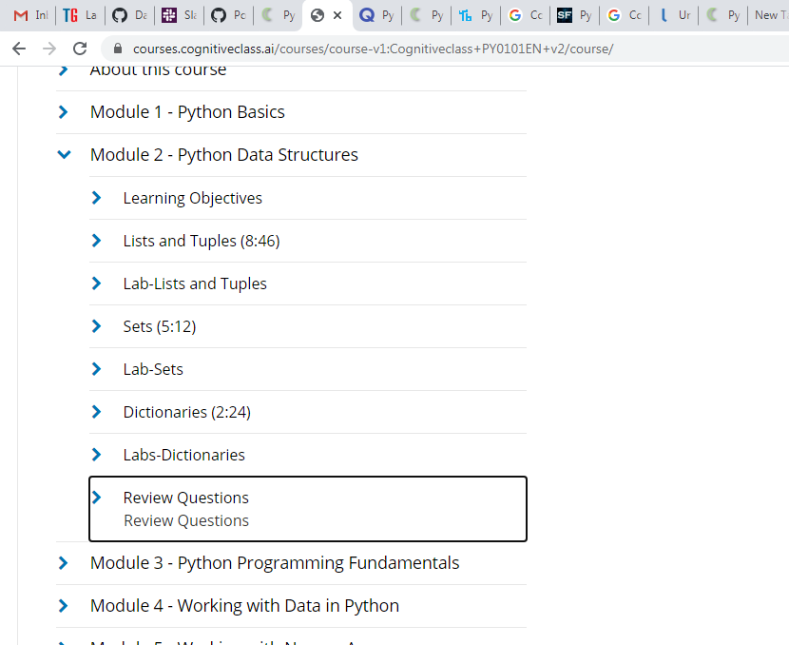

**DICTIONARIES :**

